IN THE DISTRICT COURT OF APPEAL OF THE STATE OF FLORIDA
FOURTH DISTRICT, 110 SOUTH TAMARIND AVENUE, WEST PALM BEACH, FL 33401

March 26, 2024

VLADIMIR MOSIA and MIG EXPRESS CORP.,  Appellant(s)  v.  JAMES FOGLIA,  Appellee(s). | CASE NO. - 4D2024-0179  L.T. No. - COWE230000949

BY ORDER OF THE COURT:

ORDERED that Appellants’ February 28, 2024 motion to relinquish jurisdiction is denied as moot.

Served:
Scott M. Behren
Broward Clerk
Steven Zakharyayev

CT

I HEREBY CERTIFY that the foregoing is a true copy of the court’s order.

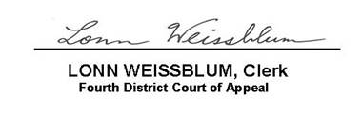  4D2024-0179 March 26, 2024  LONN WEISSBLUM, Clerk  Fourth District Court of Appeal  4D2024-0179 March 26, 2024 | 